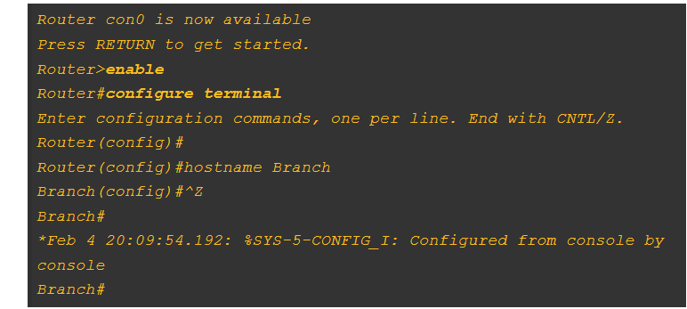

Saving Configuration

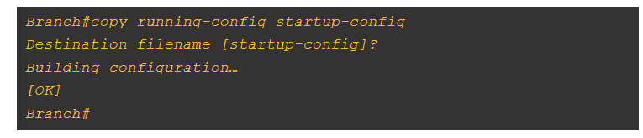

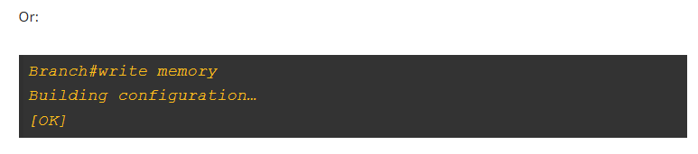

Console-Line Commands

Another important function in configuring the router is security and access control. The first command there could mitigate the exposure caused by lack of physical security. If someone accesses the console, and they suddenly leave, someone else could come in and use that session to their advantage: view the configurations, view the passwords, or even change them. The **exec-timeout**command allows you to set up a time out for command-line interface shells. In example, the console connection will time out and relogin the users after 20 minutes and 30 seconds.

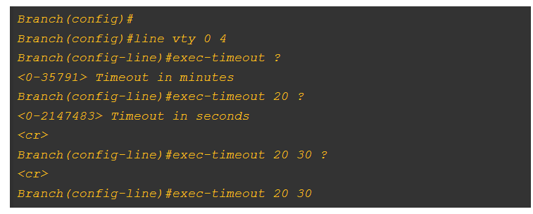

Configuring IP Address

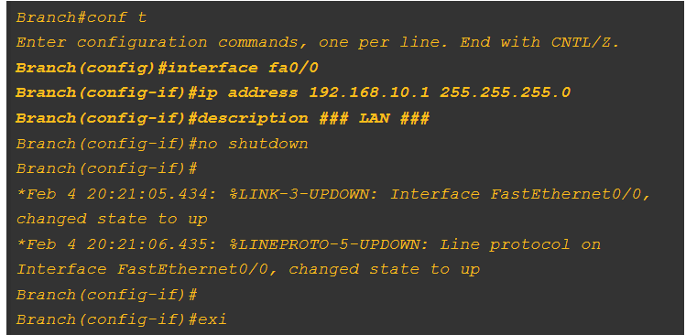

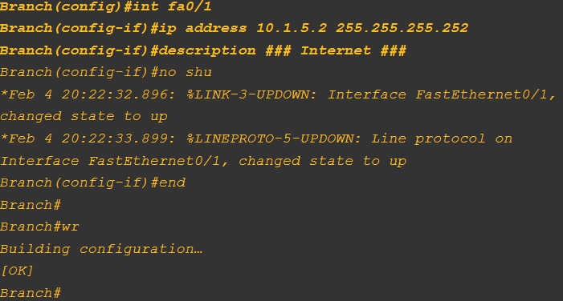

## Router show interface Command

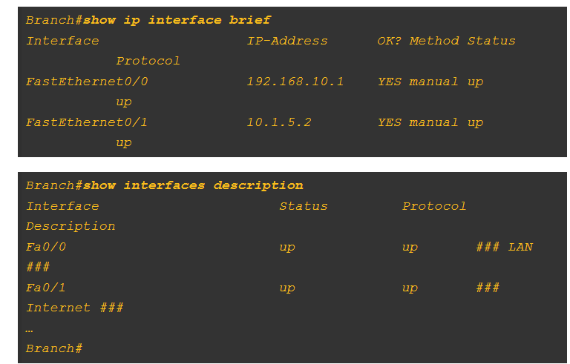

*Router#sh int fa 0*

*Router(config-if)#do sh ip int brie*

# Steps to Configure Initial Router Settings

• [Read](javascript:void(0))

• [Discuss](javascript:void(0))

Pre-requisite: [Cisco Router basic commands](https://www.geeksforgeeks.org/cisco-router-basic-commands/).

Routing is the method of selecting a network packet path over the Internet or between or through multiple networks. Routing is conducted on many kinds of networks, including circuit-switched networks, such as public switched telephone networks (PSTN), and computer networks, such as the Internet.

In this article, we will see configure the router in  Cisco Packet Tracer.

### Steps to Configure the Router:

**Step 1.**Open the packet tracer desktop and take a Router (2911) and PC0  from the devices.

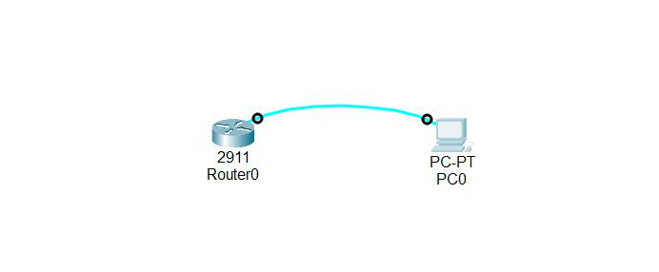

* Connect the router0 with PC0 with the help of a console cable.
* Then, click on PC0 and go to the terminal, and type y.
* Finally, we can configure the router with the help of a PC.

**Step 2:** Configure the Host name of the router0.

* Click on PC0 and go to the terminal.
* Then change the hostname to “r1”

router>

router>en

router#conf t

router(config)#hostname r1

r1(config)exit

**Step 3**: Set a message of the day (MOTD) banner for the users.

r1(config)#banner motd $

then, enter MOTD and end it with ‘$’ to exit.

r1(config)#banner motd $

Enter TEXT message. End with the character '$'.

Unauthorised access is strictly prohibited

$

**Step 4:**setting up line control password and enable secret password

To configure the Line Control password and Enable secret follow the below commands:

r1#conf t

r1(config)#

r1(config)#line con 0

r1(config-line)#password GFG123

r1(config-line)#login

r1(config-line)#exit

r1(config-line)#enable password cisco

r1(config)#enable secret GFG@123

r1(config)#service password-encryption

sh(config)#exit

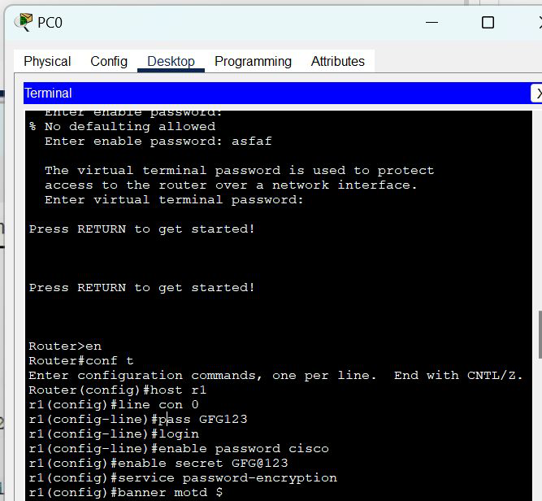

**Step 5:**Verifying password

* When you try to log in first, it will ask for the line control password.
* Then, to configure the terminal it will ask to enable a secret password.

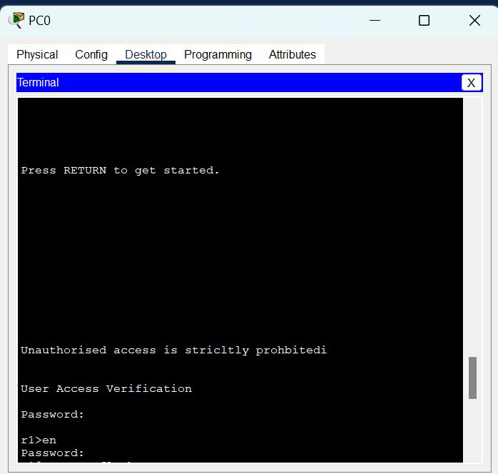

To save the configuration use the below command:

r1#copy run startup-config

Whether you're preparing for your first job interview or aiming to upskill in this ever-evolving tech landscape, [GeeksforGeeks Courses](https://www.geeksforgeeks.org/courses?utm_source=geeksforgeeks&utm_medium=article_bottom_text&utm_campaign=courses" \t "_blank) are your key to success. We provide top-quality content at affordable prices, all geared towards accelerating your growth in a time-bound manner. Join the millions we've already empowered, and we're here to do the same for you. Don't miss out - [check it out now!](https://www.geeksforgeeks.org/courses?utm_source=geeksforgeeks&utm_medium=article_bottom_text&utm_campaign=courses)